Back Up and Restore Outlook

Backup:

Backing up Outlook is really a simple matter of copying the Outlook folder to a safe location. The hardest part is getting to the folder. And even that's not particularly difficult.

If you're using Outlook 2007, select Tools, then Account Settings. For version 2010, click the File tab, then the Info option in the left pane, then Account Settings, and Account Settings again. (Yes, that's redundant.)

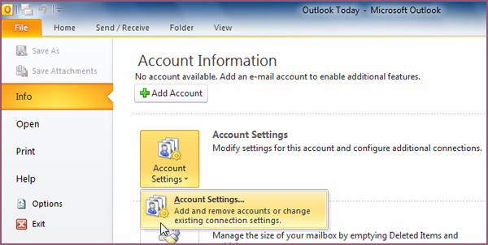

In either version, this will bring you to the Account Settings dialog box, where you should click the Data Files tab. Select your Outlook Data File, then click the Open Folder button (version 2007) or the Open File Location button (2010).

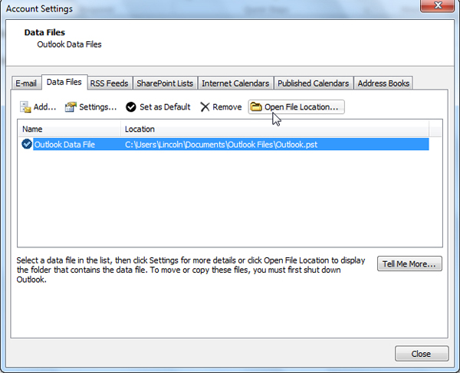

The folder containing your Outlook data will open in Windows Explorer. Return to Outlook, close the Account Settings dialog box, then close Outlook.

Back in Windows Explorer, copy the contents of this folder to a safe location, such as an external hard drive.

That's it. Outlook is backed up. Now let's jump ahead to that day you need to restore that data.

Restore:

Once you have Outlook running, start the Import and Export wizard: To do so in Outlook 2007, select File, then Import and Export. In Outlook 2010, click the File tab, the Open option on the left, then the Import option.

Once the wizard is up, select Import from another program or file and click Next.

For the file type, select Personal Folder File (.pst).

After you click Next, click the Browse button and find the backed up Outlook folder. Select the appropriate file (probably Outlook, or Outlook.pst if you have Windows set to show file extensions).

As you go through the rest of the wizard, select Personal Folders, make sure Include subfolders is checked, and click Finish.

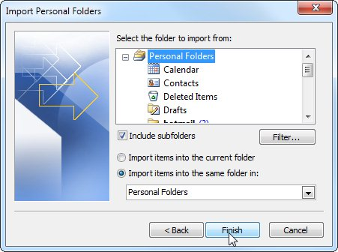

Your old data will be restored.